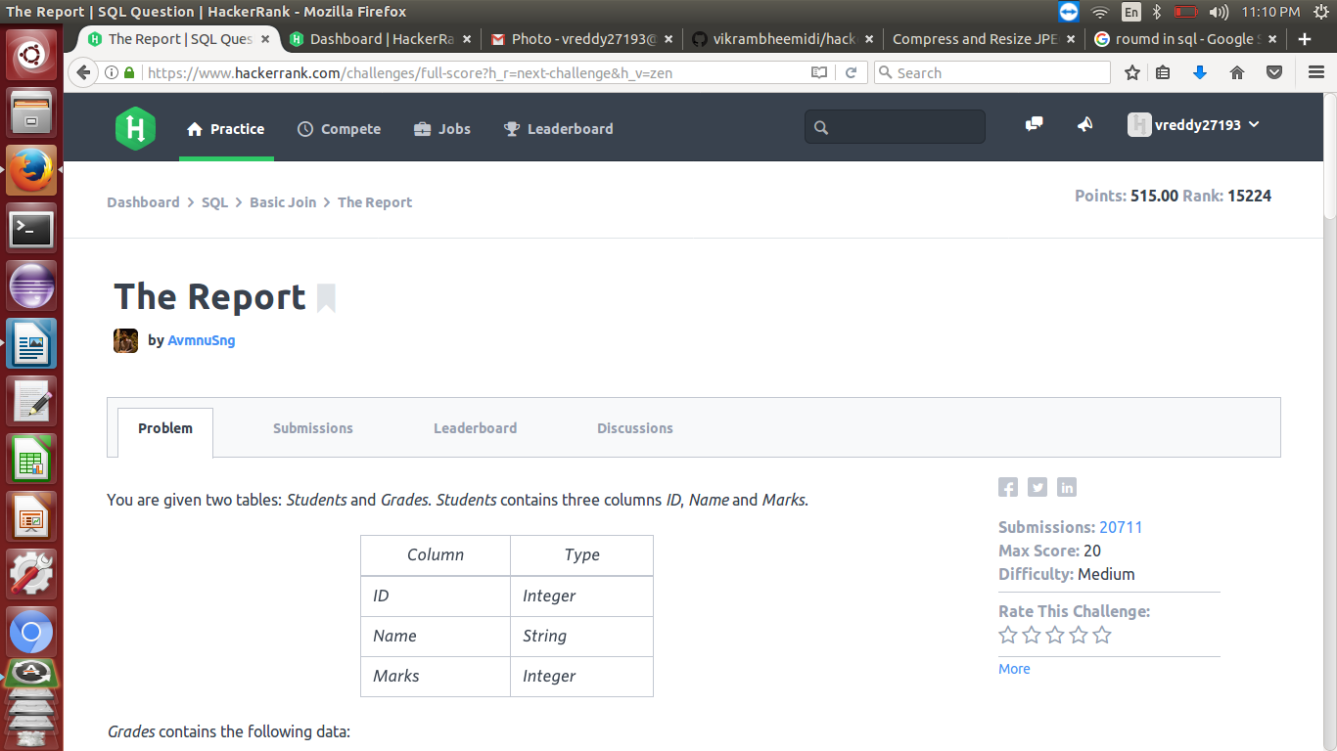
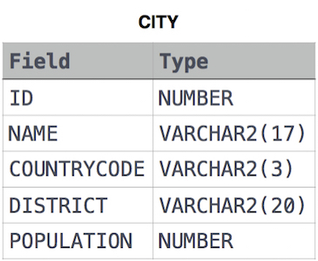

1)Query all columns for all American cities in CITY with populations larger than 100000. The CountryCode for America is USA.
---select * from CITY where POPULATION>100000 and COUNTRYCODE="USA"
2)Query the names of all American cities in CITY with populations larger than 120000. The CountryCode for America is USA.
---select NAME from CITY where POPULATION>120000 and COUNTRYCODE="USA"
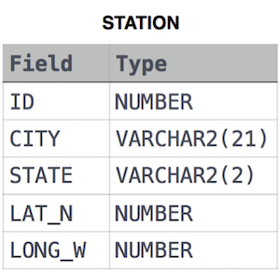

1)Query the greatest value of the Northern Latitudes (LAT_N) from STATION that is less than . Truncate your answer to decimal places.
---select round(LAT_N,4) from STATION where LAT_N<137.2345 order by LAT_N desc limit 1

2)Query the Western Longitude (LONG_W) for the largest Northern Latitude (LAT_N) in STATION that is less than 137.2345. Round your answer to decimal places.
---select round(LONG_w,4) from STATION where LAT_N<137.2345 order by LAT_N desc limit 1

3)Query the smallest Northern Latitude (LAT_N) from STATION that is greater than 38.770 . Round your answer to 4 decimal places.
---select round(LAT_N,4) from STATION where LAT_N>38.7780 order by LAT_N asc limit 1

4)Consider p1(a,b) and p2(c,d)to be two points on a 2D plane where (a,b) are the respective minimum and maximum values of Northern Latitude (LAT_N) and are the respective minimum and maximum values of Western Longitude (LONG_W) in STATION.
Query the Euclidean Distance between points and and format your answer to display decimal digits.---select round(sqrt(power(max(LAT_N)-min(LAT_N),2)+power(max(LONG_W)-min(LONG_W),2)),4) from STATION
5)A median is defined as a number separating the higher half of a data set from the lower half. Query the median of the Northern Latitudes (LAT_N) from STATION and round your answer to 4 decimal places.
---Select round(S.LAT_N,4) mediam from station S where (select count(Lat_N) from station where Lat_N < S.LAT_N ) = (select count(Lat_N) from station where Lat_N > S.LAT_N)

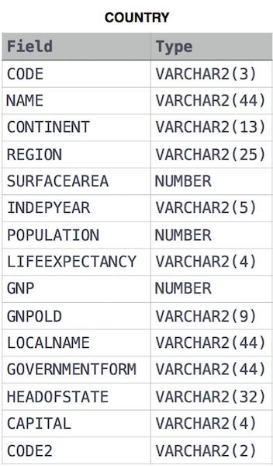

1)Given the CITY and COUNTRY tables, query the sum of the populations of all cities where the CONTINENT is 'Asia'.
Note: CITY.CountryCode and COUNTRY.Code are matching key columns.
---select sum(CITY.POPULATION) from CITY,COUNTRY where CITY.COUNTRYCODE=COUNTRY.CODE and CONTINENT='Asia'

2)Given the CITY and COUNTRY tables, query the names of all cities where the CONTINENT is 'Africa'.
---select CITY.NAME from CITY,COUNTRY where CONTINENT="Africa" and CITY.COUNTRYCODE=COUNTRY.CODE

3)Given the CITY and COUNTRY tables, query the names of all the continents (COUNTRY.Continent) and their respective average city populations (CITY.Population) rounded down to the nearest integer.
---select COUNTRY.CONTINENT,floor(avg(CITY.POPULATION)) from CITY,COUNTRY where CITY.COUNTRYCODE=COUNTRY.CODE group by COUNTRY.CONTINENT

4)Ketty gives Eve a task to generate a report containing three columns: Name, Grade and Mark. Ketty doesn't want the NAMES of those students who received a grade lower than 8. The report must be in descending order by grade -- i.e. higher grades are entered first. If there is more than one student with the same grade (8-10) assigned to them, order those particular students by their name alphabetically. Finally, if the grade is lower than 8, use "NULL" as their name and list them by their grades in descending order. If there is more than one student with the same grade (1-7) assigned to them, order those particular students by their marks in ascending order.
---select if(grade >=8, name, null), grade, marks from students, grades where marks between min_mark and max_mark order by grade desc, name

